
Amazon Interview Worksheet
DIVE DEEP
Definition and Indicators
Dive Deep: Leaders operate at all levels, stay connected to the details, audit frequently, and are skeptical when metrics and anecdote differ. No task is beneath them.
What this looks like in Practice
As a people manager do you… | As an individual contributor do you…
- Not pass the buck on unwanted tasks, demonstrate hustle and a ‘do what it takes’ attitude to get things done, even if that means being hands-on?
- Stay closely connected to the details of projects/business, knowing when to get involved without micromanaging?  - Frequently “audit” by drilling down into projects/business, questioning and providing feedback, quickly assessing progress and risk, and hold employees accountable for results?  - Drill down on fuzzy information, refusing to accept generalizations or light-weight responses? | - Have a firm grasp of the details of your work in order to deeply discuss it?  - Frequently “audit” your work by checking accuracy, facts and assumptions?

Dive Deep - Suggested Behavioral Interview Questions
For each question you choose, use a separate STAR Worksheet
Questions for (Manager) in parentheses

- Tell me about a time you were trying to understand a problem on your team and you had to go down several layers to figure it out. Who did you talk with and what information proved most valuable? How did you use that information to help solve the problem?
- Tell me about a problem you had to solve that required in-depth thought and analysis? How did you know you were focusing on the right things?
- Tell me about a time when you linked two or more problems together and identified an underlying issue? Were you able to find a solution?
- Walk me through a big problem or issue in your organization that you helped to solve. How did you become aware of it? What information did you gather, what information was missing and how did you fill the gaps? Did you do a post mortem analysis and if you did what did you learn?
- Can you tell me about a specific metric you have used to identify a need for a change in your department? Did you create the metric or was it already available? How did this and other information influence the change?
- Give me a situation in which it took you asking why five times to get to the root cause.
- As a manager, how do you stay connected to the details while focusing on the strategic, bigger picture issues? Tell me about a time when you were too far removed from a project one of your employees was working on and you ended up missing a goal (Manager)
- When your direct reports are presenting a plan or issue to you, how do you know if the underlying assumptions are the correct ones? What actions do you take to validate assumptions or data? (Manager)

STAR WORKSHEET
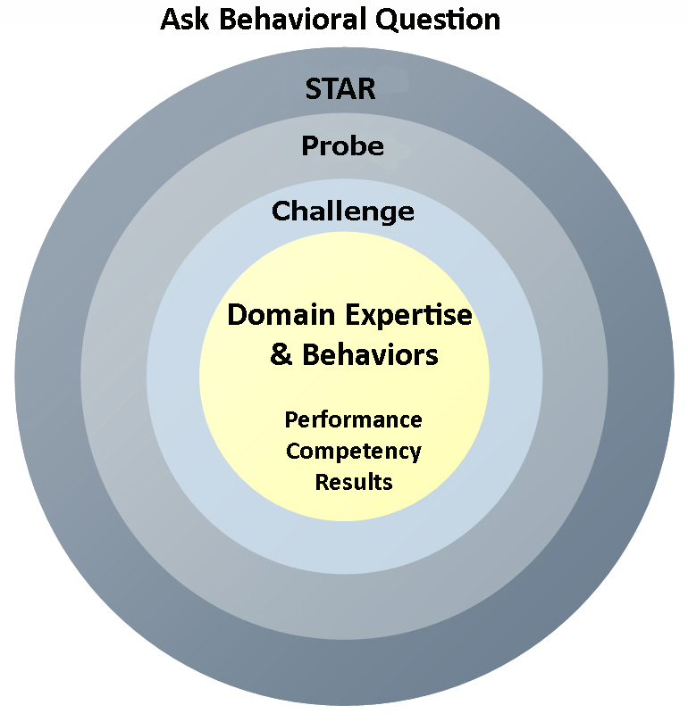
Your Behavioral Question:___________________________________________________________________Leadership Principle:_________________

- Choose behavioral question that provoke specific examples or stories for your assigned Leadership Principle(s).
- Process the example using STAR. Stories have beginnings (Situation/Task), middles (Actions) and ends (Results).
- Once you have established the story, PROBE to dive deeper on your assigned competency (Leadership Principle), get clarity or pursue a concern.
- If appropriate, CHALLENGE the candidate’s statements, decisions or thought process.
S  T | SITUATION/TASK - Describe the situation/task you faced and the context of the story  Answers the questions: where did this occur, when did it happen, why is it important?  Probing Questions:  - Why is this important? What was the goal?  - What was the initial scope of the project? What were the challenges?  - What were the risks and potential consequences if nothing happened?  Challenge Questions:  - Why did you choose this story to illustrate a xyz accomplishment?  - What other stories can you think of that demonstrate.. xyz?  - Could you come up with an example that is more recent? | Notes
A | ACTION - What actions did you take?  Answers the questions: what did you personally own, how did you do it, who else was involved?  Probing Questions:  - Deep probe functional expertise and/or assigned core competency.  - Were you the key driver or project owner?  - What was your biggest contribution? What unique value did you bring?  - What were the most significant obstacles you faced? How did you overcome them?  Challenge Questions:  - What did you do specifically versus the team?  - How did you set priorities…deal with xyz problem… or get manager buy-in?  - What decisions did you challenge? Why? How did you influence the right outcome?
R | RESULTS - How did you measure success for this project? What results did you achieve?  $ Cost savings, revenue generation  # Quantify to understand volume, size, scale  % Percentage change, year over year improvements  Time to market, implementation time, time savings  Impact on the customer, the team  δ Quality improvements  Probing Questions:  - Why did you choose to focus on these results? What other results were important?  - You mentioned revenue, what percentage change is that year over year?  - What trade-offs did you have to make to achieve this? (quality, cost, time)  - I’m concerned about… (the time it took, the volume, the customer impact), tell me more…  Challenge Questions:  - What were the lessons learned? What would you have done differently?  - How would you implement this at Amazon?  - How did these results compare to your actual goals? (refer back to goal stated in Situation)

